## Description

Architect and design software for a bare-metal embedded system used in a temperature monitoring and visualization device, with indicators for OK, Warning, and Critical temperature ranges.

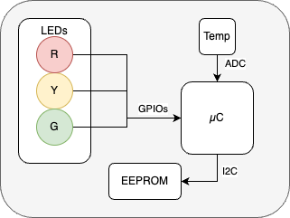

## Requirements

* Temperature sensor is connected via ADC.
* Temperature shall be sampled every 100µs, with very low jitter.
* 3 LEDs are connected via GPIOs, which shall visualize Temperature conditions.
  + G - Normal operation temperature <85degC
  + Y - Temperature reached warning level >= 85decC
  + R - Temperature is at critical level >= 105degC
* The software shall support two different hardware revisions, each equipped with different temperature sensor types:
  + Rev-A has a resolution of 1 degree Celsius per digit. For example, a value of 10 corresponds to 10 °C.
  + Rev-B has a resolution of 0.1 degrees Celsius per digit. For example, a value of 100 corresponds to 10 °C
  + Only one type of sensor type will be operational at any given time
* EEPROM provides configuration like:
  + Hardware revision (0 – Rev-A, 1 – Rev-B).
  + Hardware serial number (used as placeholder only, for example: “ABC1234”)

## Implementation

* Software shall be written in C language.
* For demonstration purposes, the software can be written for a PC with mocked hardware interfaces. No hardware implementation, nor emulation is required.
* If an ISR is needed, a function shall be defined and implemented; however, there is no need to make the ISR calls functional from PC demonstration program.
* Rewrite the software in C++.